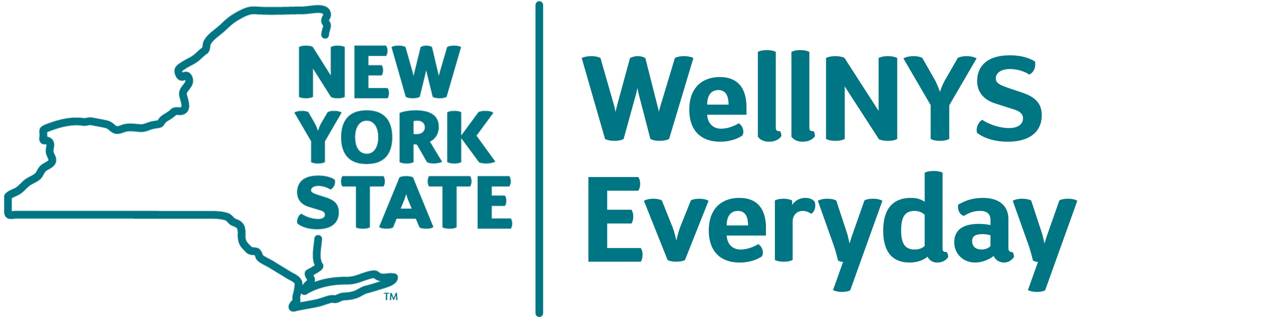

WellNYS Everyday Monthly Webinar
24 Healthy Habits
to Begin in 2024
That Take Only Two Minutes

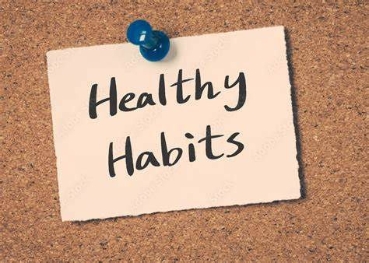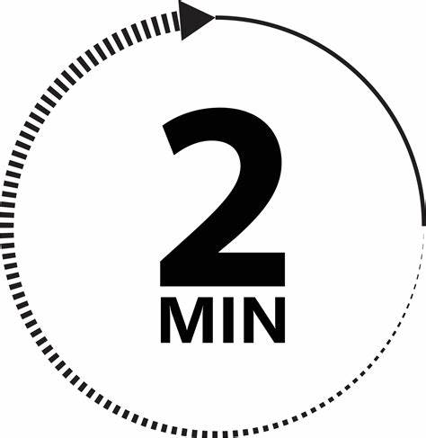

Wednesday, December 6, 2023
12:00 noon – 12:30 P.M.

The year 2024 is a few weeks away. The beginning of the year is a great time to begin a healthy habit. To establish a healthy habit, start by engaging in it for two minutes. Join us for the final wellness webinar of 2024 as we share 24 Healthy Habits that only take two-minutes.

Presented by:
Linda Carignan-Everts
WLS Wellness Coordinator

To register for this webinar
Go to https://meetny.webex.com/weblink/register/rc6f381a633701e21e3803e191cf4a936

You will receive a confirmation email with instructions for joining the session. This session will be recorded and made available on the WellNYS Everyday website.

Work-Life Services (WLS) Programs are joint labor-management programs that benefit New York State employees by enhancing employee wellbeing, increasing productivity, and improving morale in the workplace. The WLS programs include the Employee Assistance Program, Network Child Care Centers, and DIRECTIONS: Pre-Retirement Planning. The WLS programs are funded through the collective bargaining agreements between the State of New York and the public employee unions: CSEA, PEF, UUP, NYSCOPBA, GSEU, Council 82, and DC-37 and PNANYS. The Office of Employee Relations contributes on behalf of management/confidential employees.

