*Information in FrontLine Employee is for general informational purposes only and is not intended to replace the counsel or advice of a qualified health or legal professional. For further help, questions, or referral to community resources for specific problems or personal concerns, contact a qualified professional. Add “http://” to source links to follow. Link titles are always case sensitive. The views and opinions expressed herein are solely attributable to DFA publishing).  None of the views or opinions expressed in this publication reflect the views or opinions of the NYS EAP or the NYS Office of Employee Relations.*



***Wellness, Productivity, and You!***

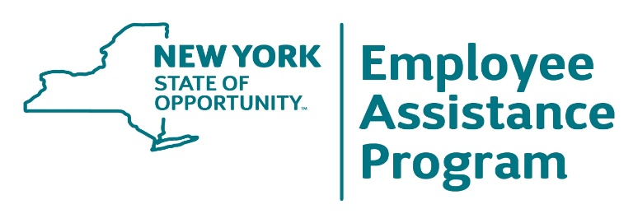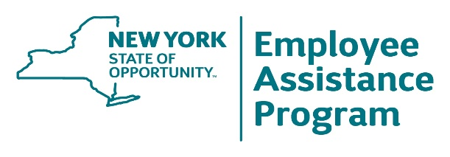

**1-800-822-0244  
www.oer.ny.gov/eap**

**September 2023**

Impress the Boss with Your Reliability

Have You Added Plants   
to Your Workspace Yet?

Coping with the

Sunday

“Scaries”

Stress Tips from the Field:   
Newly Divorced   
 Stress

**End of summer is a time** when

many divorces occur. If you’re

newly divorced, serious stress

can naturally follow your decision,

regardless of how tough it was to

make. Emotional stress is

common among divorced couples, includes grief and sadness, and negatively affects self-esteem. Other stresses, such as coparenting challenges, financial concerns, and navigating changes in your social life, can also be challenging. Your goal is to create a new life with new routines. Don’t go it alone or remain in isolation. Bring tough challenges to your employee assistance program to get the support you need.

**The Sunday “scaries”** refers

to that sinking feeling or anxiety

some people experience on

Sunday night when they

realize the weekend is over

and Monday morning will soon

arrive, and along with it what

awaits at work. Gain control over this state of mind by jotting down your tasks and goals for the week. You will feel more control and quickly dispel the sense of dread. Anxiety is often reduced by self-care techniques, so experiment with an enjoyable form of relaxation. For more impact, incorporate this into a regular evening routine. Try a bit of “thought blocking” replaced with an activity that keeps your mind occupied. Plan your Monday on Friday by taking a bit of time to go over your schedule for the next week. You’re more likely to stay in the present come Sunday night.

**Reliability is a soft** skill

valued by employers because

reliable employees demonstrate

consistent results with accuracy

and achievement. They also

help reduce supervisor stress

about outcomes, predictability,

and timely communication. To

ramp up your reliability, you

need to deliver consistent,

high-quality work and let your

boss’s positive response

motivate you to consistently perform in this way. Take the initiative by identifying issues or problems upstream and resolving them before management is forced to resolve them. Be adaptable to sudden change, and develop a sense for what, how much, and when your boss needs to communicate.

**Indoor plants have** been

shown to favorably impact

individuals’ physiological and

cognitive functions. One study

even showed their presence

can lower blood pressure.

Indoor office lighting is

suitable for many kinds of

plants, including the following:

snake plant, ZZ plant, peace

lily, pothos, Chinese evergreen,

and dracaena. So, get some healthy greens on your desk by searching images of these plants to see which ones will work for you.

Source: Effects of Plants at [www.ncbi.nlm.nih.gov/pmc/articles/PMC9224521/](http://www.ncbi.nlm.nih.gov/pmc/articles/PMC9224521/)

.



Learn more: <http://www.justthinktwice.gov/article/drug-alert-marijuana-edibles>

**No** **matter where** you

live, a natural disaster

or catastrophe can

happen. Are your family

and home prepared to

face an event that could

completely upend your

life? Denial (“it won’t

happen here

(or to me)”) and

procrastination in

taking preparatory

steps are your worst enemies. Find information and steps to take, along with guidance and checklists, at [www.ready.gov](https://www.ready.gov/). After experiencing the effects of a disaster or catastrophe, be mindful of signs or symptoms indicating a need for mental health support—such as emotional distress that lingers, sleep disturbances, somatic or physical symptoms like headaches and gastrointestinal distress, or a desire to withdraw or remain isolated.

**The diminishing** stigma

of seeking professional

mental health counseling

is a positive

development. However,

it’s worth noting that

many concerns presented

to counselors can be

resolved through

alternative means. A few

misconceptions often

prompt seeking a professional counselor when one might not be needed. These include: 1) believing there are no alternative resources, such as self-help strategies, support networks, or community resources, including EAP; 2) linking emotional distress with the notion that seeking professional help is essential for thorough and ultimate resolution; 3) believing a professional counselor will provide an unheard-of, inspiring, or motivational answer to a personal problem that instantly resolves it; and 4) using a professional counselor as a procrastination step to intellectualize (examine, analyze, rehash) the nature of a problem to feel as though one is making progress, while one is only resisting or procrastinating in the taking of action steps needed to create change.

**The Centers for Disease** Control

and Prevention reports a significant

increase in the number of children

who have consumed marijuana

edibles leading to the need for

emergency medical assistance. A rise

of 214% in emergency room visits by children under the age of 11 has occurred in the past two years. Eating products of any kind that include THC is more dangerous than smoking cannabis due to both the unpredictable and inconsistent amounts of THC added to these products and the tendency to consume more of the cannabis product, especially if the intoxicating effects of THC are not immediately felt. With 23 states now legalizing cannabis for recreational use, this health risk is not likely to diminish. Marijuana edibles can create psychotic effects and may not be much different in appearance from a gummy vitamin. Parents should follow these six guidelines regarding teen and child substance abuse prevention: 1) provide accurate education about risks and legal consequences of substance abuse; 2) discuss peer pressure and how to respond to it effectively; 3) educate young people early about stress management and coping strategies; 4) practice, model, and encourage open communication about issues and concerns young people experience; 5) discuss expectations and boundaries for your family regarding substance abuse and what the consequences will be for crossing these boundaries; and 6) know where to get help, information about counseling, or early intervention when you suspect your child is using illicit substances. Begin this search via your employee assistance program.

**Do you feel bored** with your job,

unable to leave, and helpless to

change your state of mind? There

are personal interventions you can

try that have worked for others. Start

by taking time to think about your

interests, goals, and values (what’s

most important to you in your life).

Next, search for how these things

are hidden within the scope of your job’s essential functions. Don’t be too quick to say, “There’s nothing!” For example, do you value “meaningful relationships”? If so, can you make your job more meaningful by mentoring others, being more helpful, collaborating, engaging more empathetically, and lessening your isolation? These behaviors have ripple effects at work and can lead to more positive interactions, cooperation, teaming, and sharing of ideas.

September 2023 FrontLine Employee

Is There Hidden Meaning   
 in Your Job?

Prepare for Disasters   
and Catastrophes

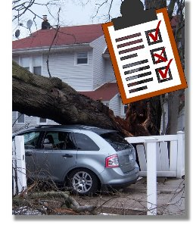

Marijuana Edibles: What Parents  
Should Know

You Probably Don’t  
 Need Counseling   
 for That